Mitushi Pradeep

Department of Information Technology and Management,

Illinois Institute of Technology  
+1 5055675619, IL, 60616

[mpradeep@hawk.iit.edu](mailto:mpradeep@hawk.iit.edu)

Saurabh Pisal

Department of Information Technology and Management,

Illinois Institute of Technology  
+1 3128047225, IL, 60616

[spisal@hawk.iit.edu](mailto:spisal@hawk.iit.edu)Anali Inamke

Department of Information Technology and Management,

Illinois Institute of Technology  
+1 7085109230, IL, 60616

[ainamke@hawk.iit.edu](mailto:ainamke@hawk.iit.edu)

Gabriel Garcia Ardiles

Department of Information Technology and Management,

Illinois Institute of Technology  
+1 3122866033, IL, 60616

[ggarciaardiles@hawk.iit.edu](mailto:ggarciaardiles@hawk.iit.edu)

Ajay Joglekar

Department of Information Technology and Management,

Illinois Institute of Technology  
+1 3127147422, IL, 60616

[ajoglekar@hawk.iit.edu](mailto:ajoglekar@hawk.iit.edu)

**ABSTRACT**

In today's world, internet has become a continuously growing market for companies and, consequently, revolutionized the shopping industry. E-commerce websites help customers purchase and sale goods and services via electronic channels such as the Internet. For the customer, this means that nearly everything can be ordered online and comfortably be delivered to their house. For the seller, it translates in modified logistics but cheaper storage costs. E-commerce consists essentially of the distributing, buying, selling, marketing and servicing of products or services over the Internet. This changing market represents a huge opportunity for businesses to improve their relevance and expand their market in the online world. We will analyze the challenges that new eCommerce companies have to overcome and propose service improvements that can make them compete with the well established big companies in the online market.

# 

# KEYWORDS

ITIL; SMP; eCommerce; Bewakoof; Enhancement; Shutter 360 degree; Q/A;

# 1. OVERVIEW

## Bewakoof is an Hindi word for Foolish. But what does society call Bewakoof? It is anything distinctive or that is done uniquely. In other words, when people have done the correct thing, without caring about what society believes, they have been called Bewakoof. These are the people who have impacted the world in some level and made it a better place.

## At a time when Indian e-commerce organizations were not able to be highly profitable, Bewakoof.com launched in April 2012, declaring today to have resisted the downtrend and quadrupling its sales each year. Bewakoof.com claims to be a profitable e-commerce site, eyeing a turnover of over Rs 10 crore in the current fiscal year. Co-founder Prabhkiran Singh stated that bewakoof.com is self-sustainable and growing twenty percent every month [1].

## Launched on April 1, 2012, by IITians Prabhkiran Singh and Siddharth Munot, Bewakoof.com has relied on quirky, humorous, out-of-the-box messaging on its products to connect with its customers[1].

# 2. CHALLENGES

If we take a look back eCommerce platforms have been around for over 10 years. In all that time, these sites have been introducing new concepts and features dynamically so companies like Amazon or Ebay do not look anything similar to how they looked back in 2008. Difficulties arise for new eCommerce sites not yet settled in the market as they have to keep up with the established companies. This is the case of bewakoof.com that has to come up with creative ideas to succeed in the market.

For instance, customer experience in established web pages has been carefully curated, product reviews are well presented, there is a Q/A section and the image quality of the product being sold has a very high quality. Moreover, payment is simplified and becoming a web standard so doing anything differently is just going to make the customer uncomfortable sharing their credit card information [2]. These user experience features are hard to mimic for emerging sites.

On the other end, delivery flow should be outstanding. It has to be as easy as if you were in the store to return items, in other words, customer service has to excel. It should be fast, friendly and with a close language to the user, just like if you were talking to a friend.

Another aspect to consider is innovation. The big companies already offer a great service for selling products online so a new company should offer some added value that the customer cannot already find. It should be well thought by the service improvement team as to provide the platform with innovative ideas that make a difference.

# 3. SCOPE

## This document applies to bewakoof.com line of IT Services that are currently provided to their online customers. This plan will be effective from June 1, 2018 to Dec 31, 2018.

# 4. OBJECTIVES

## As a result of the Service Improvement Initiative Assessment, the following objectives have been identified for the Service Improvement Plan:

## 1. Innovate how items are displayed to customer.

## 2. Decrease time to solve incidents.

## 3. Improve customer satisfaction with Chatbot.

# 5. SERVICE MANAGEMENT PLAN

## This document outlines our solution to put bewakoof.com in a leading position with respect to their competition. In this way, we are going to undergo a service improvement plan consisting of the five ITIL phases where the three services will be improved in parallel. However, to increase the details of our analysis, we have explained the activities done in each ITIL phase individually in every subsection. This doesn’t mean that we improved the services sequentially.

# 6. AI CHATBOT

It's frustrating for a customer to wait for a customer service representative to respond to their request. Excessive waiting leads to bad reviews by the customer and often losses in sales.

By introducing chatbots that are programmed to solve the most frequent issues and the use of Artificial Intelligence to learn how to solve new issues as they appear in their Knowledge Base we can greatly improve the company's customer service at a fraction of the cost. IBM assures in their study of AI Chatbots that these tools could increase savings for businesses from $21M in 2017 to $8B in 2022 [3].

## 6.1 Service Strategy

As a business we need to provide fast support to customers that have had a problem and want to find a quick answer. However, this normally means having a huge team of customer service representatives that have to be trained on the specifics of a piece of software as well as on how to communicate well with a customer. It is normally very unpleasant for a customer to wait in line for a representative to be available. Therefore, there is need to improve this in an innovative way that stands out from the competition and makes bewakoof.com lead on customer satisfaction among the ecommerce industry in India.

To supplement our customer service capabilities we are going to design and implement a chatbot that is loaded by two of our trained senior customer representatives and is able to respond to natural language questions made by the customers [4]. We are going to allocate a team of three of our software engineers leaded by our Director of Engineering. Of those three engineers, the team lead design the technical aspects to be implemented and our senior customer representatives will participate in the education of the system, increasing the knowledge base of actions it can provide.

From the financial standpoint, this project will make bewakoof.com less costly as it will reduce the amount of customer representatives needed to support the average rate of claims received by the system [5]. In the end, we should see a 30%-40% decrease in calls to customer service, by a system that not only has the only cost of maintaining some servers, but improves itself through the use of Artificial Intelligence. At the end of the day, the budgeting for our customer satisfaction department should be reduced by 30% keeping only our most senior representatives that are able to outperform our chatbot system.

An initial version will be deployed to customers in one of the smaller but younger areas of India, Bangalore, where the population is inclined to be more tech savvy. Any request coming from that certain location will receive the new version of bewakoof including our chatbot. In this way, we can start with a smaller beachhead market to test the system before making a full deployment to production. That way, our risks will be minimized since our entire staff of customer service representatives will still be on board to solve any claims made by customers. After that, other areas in India will be sequentially added by order of usage.

We will ensure that our service is functioning correctly by actively asking our users about it on the website and monitoring the usage of the chatbot through Google Analytics. We are expecting a constant increase in the usage of our chatbot and constant decay in phone calls made to our customer support centers. Also, we will instruct our representatives to encourage the users that do call to use the chatbot next time due to its reduced time to answer.

## 6.2 Service Design

In this phase we have already identified the requirements that the chatbot should have to comply with bewakoof.com business improvement needs regarding customer service and support. At this point is the time for the allocated team to design the technical aspects of the Chatbot paying special attention the User Interface design as well as the Artificial Intelligence framework that the chatbot relies upon.

The chatbot application will mimic the look and behaviour of other popular chatting applications like Facebook Messenger or Whatsapp. The chat will be embedded into the rest of the bewakoof.com website as another tab so that the user can seamlessly navigate back and forth to the chat. The chatbot initiate the conversation with any given customer in their own language and with one of several preconfigured polite greeting messages [6]. These messages conduct the user depending on which the initial response is, if they mentioned on the chatbot that they are looking for help finding a specific item the greeting will be followed by further questioning in an attempt to find that item (see figure 1).

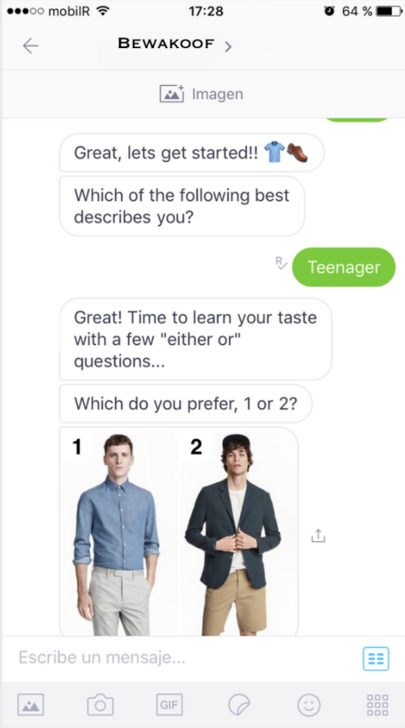

Figure 1: Chatbot Screenshot Greeting..

Then, the conversation should continue to narrow down the specific needs of the user until a satisfactory response is provided. This is when the artificial intelligence platform will perform most of its work, learning and optimizing the conditional paths to any given answer and growing its knowledge base as more and more customers interact with the system (see figure 2). Once that response is found, the system will ask the user if he or she is satisfied by the response and ask for final action, after thanking them for interacting with the chatbot.

In order to efficiently design the chatbot, different measures have to be implemented to ensure the availability is not compromised. Therefore, the chatbot will be monitored internally using Google Analytics and constant pings to the various endpoints that compose the backend of the system. Also, there will always be an in-app listener for messages like “Are you there?” that sends a signal to a crash server if the chatbot servers do not respond efficiently. The reason for such monitoring is that the most sensible piece is the artificial intelligence tool that is leveraging all the smart natural language processing translations. If that particular part were to fail the entire purpose of the chatbot would be jeopardized.

If the system completely failed, the disaster recovery plan would involve forwarding all customer support request to the representatives. However, customer service requests that didn’t involve a claim would be recommended to check out our website first as a way to prevent overloading of phone calls to our representatives.

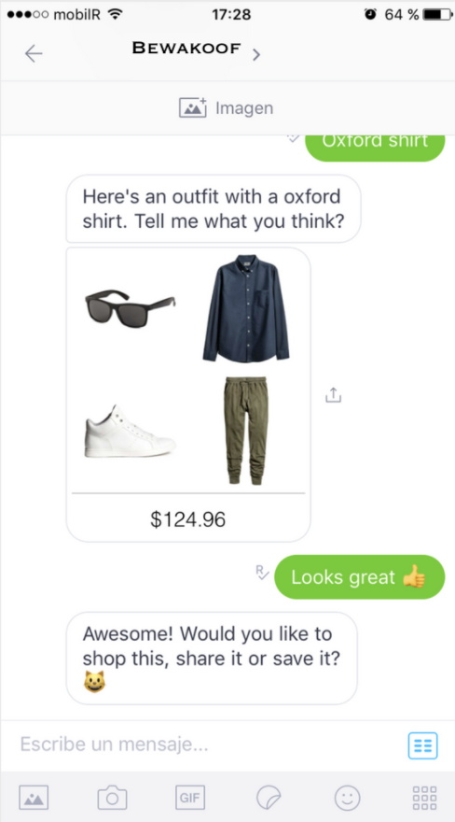

Figure 2: Chatbot Screenshot Decision Making

## 6.3 Service Transition

Once the chatbot has been designed and implemented, it is time to test the different versions of the system to ensure it will be able to handle the load of the production environment. In this phase we will follow the proposed pattern of incrementally testing the system with increasingly higher exposures to production [7]. In such a way, the chatbot will only be seen by customers from Bangalore in the first iteration. Then, sequential circles will be defined to iteratively test and improve the system as it can be seen in the map shown in figure 3. The objective of this sequential deployment is to amend and solve problems that are identified with smaller populations more inclined towards technology. After a specific zone has been cleared, the next zone is added to the system and the whole process starts over again. The deployment ends once the system has reached the majority of the indian territory and then is available to all bewakoof.com customers (zone 5).

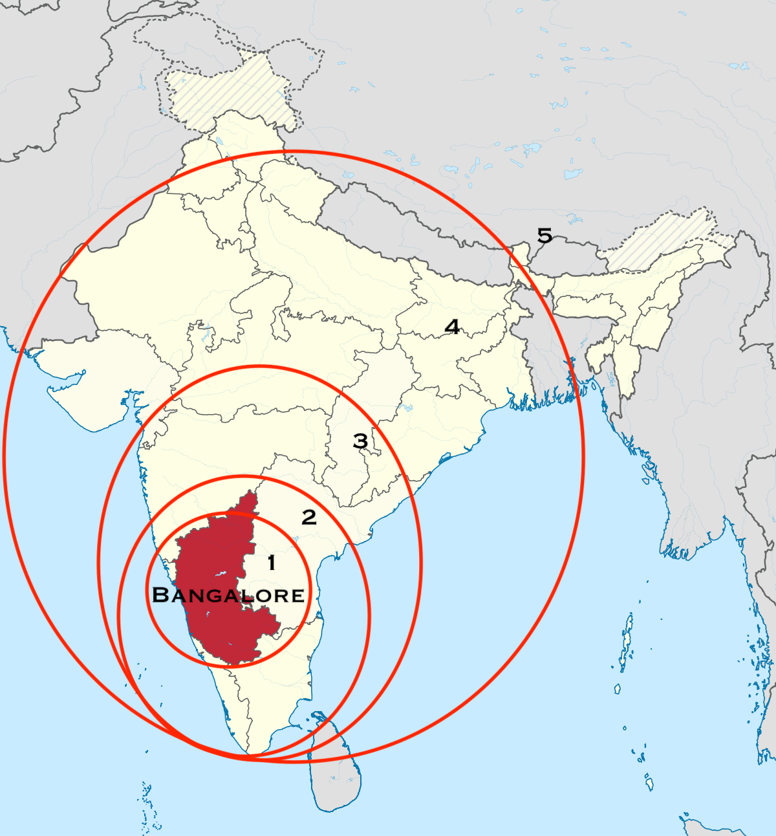

Figure 3: Iterative exposure of chatbot to customers

## As part of service transition also it is important to ensure that all capacity required to sustain the customer service needs is fully available. In other words, as the further regions are being served with the chatbot, the customer representatives count will not be reduced. After region five is reached and the system has been proven capable to reduce the load on customer representatives, then the actual number of hired representatives can start to be reduced.

## 6.4 Service Operation

At this point the service is operating in its fully developed state in all regions where bewakoof.com has presence in india. Therefore, it is time to ensure that the service is acting as expected and identify which parts of the service are not delivering the desired performance. Also, evaluation of the customer experience has to be depicted in this phase to assess if customers are indeed happier with the AI chatbot than what they were waiting in line for a customer representative to take their call.

Bewakoof.com will monitor the chatbot using Google Analytic tools to ensure that the conversations are fluent enough, therefore several metrics from proposed studies [8] will be tracked in order to ensure the system is operating accordingly to the design requirements (table CH1).

|  |  |
| --- | --- |
| Average time spent in chatbot | Pos. vs Neg. interactions |
| Average bot response time | Total Users |
| Categories asked | Average quantity of questions |
| Retention rate | Fallback rates |
| Confusion Triggers | Most used phrases |

Table CH1: Metrics used in Service Operation for AI Chatbot

These metrics along with user in-website polls asking to respond to very simple questions with a mark of 1-5 will ensure that the system is operating accordingly. Also, internally, there will be an evaluation to the customer service representatives to ensure that these are not overworking or underworking at any point and the necessary adjustments will be made to complement the AI Chatbot system.

## 

## 6.5 Continual Service Improvement

This phase will be present at the same time than the other four phases. Its main task will consist in identifying the possible inefficiencies of the systems and where improvements should be made.

Once the product has been delivered various data science procedures have to be applied to the various metrics that are being continuously measured on the system [9]. That way, bewakoof.com will be able to optimize the set of criteria that is looking at and making better judgements about where the system needs improvement. If an improvement is needed, then it will require a new business assessment on the strategy phase that will evolve into a technical implementation in the design phase and sequential deployments on the transition phase.

These phase is the wrapper of all other phases and which improves the system even further by the optimization of the metrics that are being watched on the AI chatbot.

# 7. 3-D Product Images (Mitushi pradeep, Ajay Joglekar)

## E-commerce websites having a 2-dimensional view of images have to rely on limited visual modalities consisting of text and 2D graphical images or videos of products and they are unable to feel, touch or manipulate the products through the web interfaces. Because of this limitation, the consumer affordance for searching a product that they wish to purchase is comparatively low against the traditional in-store purchases.

## Use of 3D visualization is one method that our e-commerce websites will use to overcome the existing limitations and provide a better sensory experience to their consumers. This is achieved by using a number of photos from varying angles or a 3D model of the product/object. Allowing viewing all parts of the product interactively have an effect on fast reasoning and understanding of the object by the consumer. Particularly the 360° turntable views using the actual photos are found to be more appealing to the consumers than 3D models [10].

## Interacting with an online shopping environment is affected by a number of cognitive factors. Also interactive 3D products arouse past experience, memories and feelings of consumers and provide a positive sensory experience [11]. It has been found that while interacting with 3D product visualization, consumers use almost all of their senses [12]. 3D product visualization can easily support for multi-modal interaction beyond traditional static 2D content based user interactions. Having more than one modality enables the user to perceive the product information closer to the real world as they would have experienced with the real artefact.

## 

## 7.1 Service Strategy

Variety of different software and hardware solutions are available to create and display 360° product views. The basic principle behind those is mapping the 360 degrees of space to a set of actual images taken around an object at evenly spaced angles, thus producing a pseudo-3D visualization. The 3-D product visualizations are supposed to provide just that giving the control to the user to explore the product. This has been further proven in [13] and they suggest allowing consumers to navigate and view information on any part of a product. Consumers interacting with such products are more likely to experience an increased the sense of presence [14], [15].

Our business strategy to increase sales of product and reduce replacements for purchased products, we will introduce a 360-degree view of product, this will enable a closer look at the product that customers want to buy.

Our major strategy will be to include 360-image view for all major products which has greater sales or for all products in the database. 360-images will be produced for all products on our website. one of software that will be used is 'Shutter Stream 360 Product Photography Software' tool used for creating 360 product views. Shutter Stream 360 will permit customers to easily, reliably and affordably shoot 360 image-spins sets in-local environment and design web product animations.  
Our earlier 2-D photography images provided few 5-6 images frames not giving full few 3-Dimensional view for products that customer wants.



Figure 4: 2-D Image

The proposed 3D-Model will be explained in service design stage of our project

## 7.2 Service Design

Undoubtedly, product photography is an influential factor in the eCommerce business. According to a study by R.R Donnely, 93% of customers study the visual exhibition of the product and it is the most important factor while shopping online. The product display should be clear and accurate from each angle and position.  
It's insufficient to provide a single product image in our eCommerce listing. Solely relying on vendors for product images should be reconsidered. Presenting unparalleled high-quality product images and added views of each product has its advantages. The last thing we want to have our customer to do is return the products purchased from our site because of lack of visual imagery and the difference in the pictorial and actual product. If this is the case, chances are high of losing the sale. [16]  
We here at Bewakoof.com will implement the use of Shutter Stream for capturing 360 degrees of the products.  
Shutter Stream has already proven to be a powerful photography workflow solution that has saved hundreds of businesses time, money and effort every time an image is captured. By introducing this feature, customers will be able to more closely get an idea of the product which they are planning to buy. They would be able to view the 360-degree view of the product. This would reduce the number of returns and replacements, in turn increasing the business of the company. [16].  
Shutter Stream 360 Product Photography Software is the perfect tool for creating 360 product views for our eCommerce site- Bewakoof.com. Shutter Stream 360 enables users to quickly and efficiently shoot the image of the product and it is affordable for shooting 360 spin sets in the house and create product animations for the website instantly and its viewable on both web as well as mobile devices.

Software Design

The software is designed in such a developer friendly manner that it could work with any photography and users can create, capture, edit, process, and output a 360-product view composed of 24 frames or even lesser, in approximately 5 minutes, according to the demand of the product exposure affecting its sale.  
  
   
Figure 5: 360 Shutter photography process

A team of UX (User Experience) designers will accountable for creating 360-images for the website having skills for developing images via Shutter 360 image software. Another team of Designer will take account into account how this image will appear on the website, this will involve CSS, HTML coding. All this will be managed by Designer lead for the project. All this 360-image files created on daily basis will be loaded into the database. Image file be linked to product catalog to be viewed on website. Database capacity will be increased as to store image files in system as this image files are large in size. The data load will take in smaller test environment in project for testing purpose. After few initial tests by UX Designer and project manager. Data load for image file will take place in pre-production environment and after final test. Data load will take place in production systems. An index can be placed for products having 360-image view. This index will help in determining product purchases for Data analytics purpose for calculating future trends and purchases. Release and deployment management will be later responsible for daily releases of data loads on production and another environment

**7.3 Benefits**  
Benefits of implementation of 360 product photography in our website led to the following- It include increased conversion rates, customer satisfaction, customer retention, on page visit duration and decrease product returns.  
Illustration

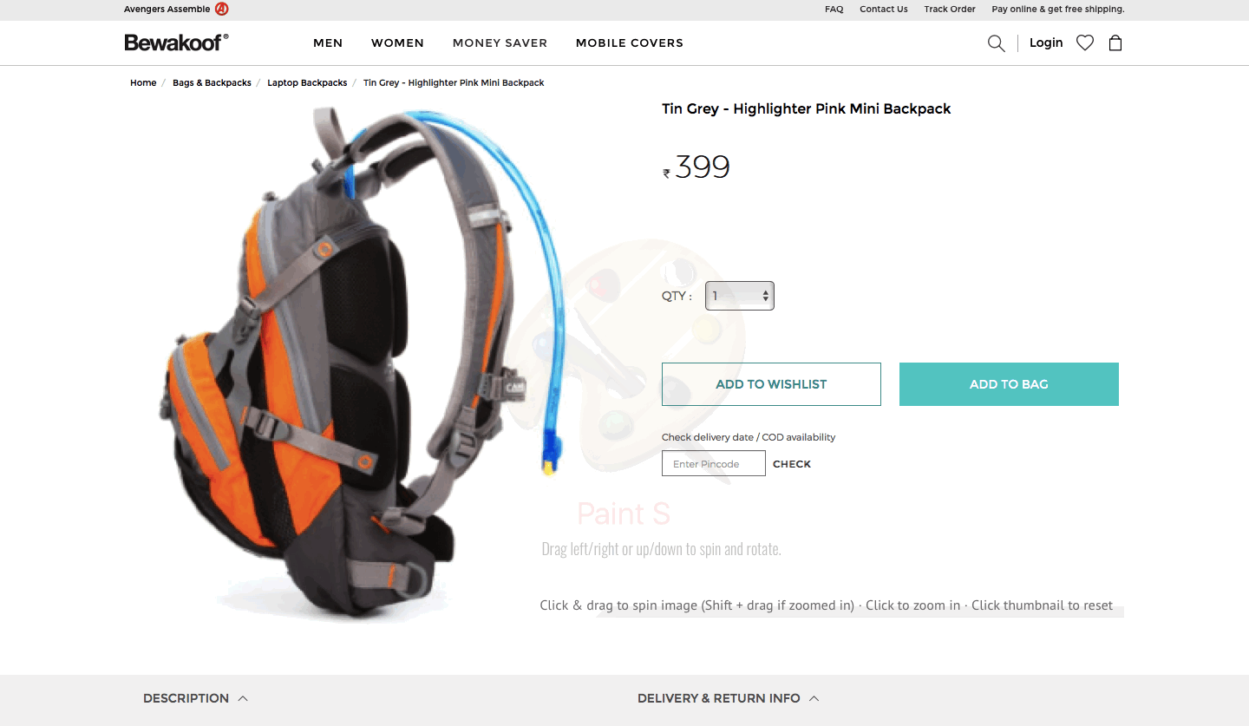  
 Figure 6: Angle 1 of the product

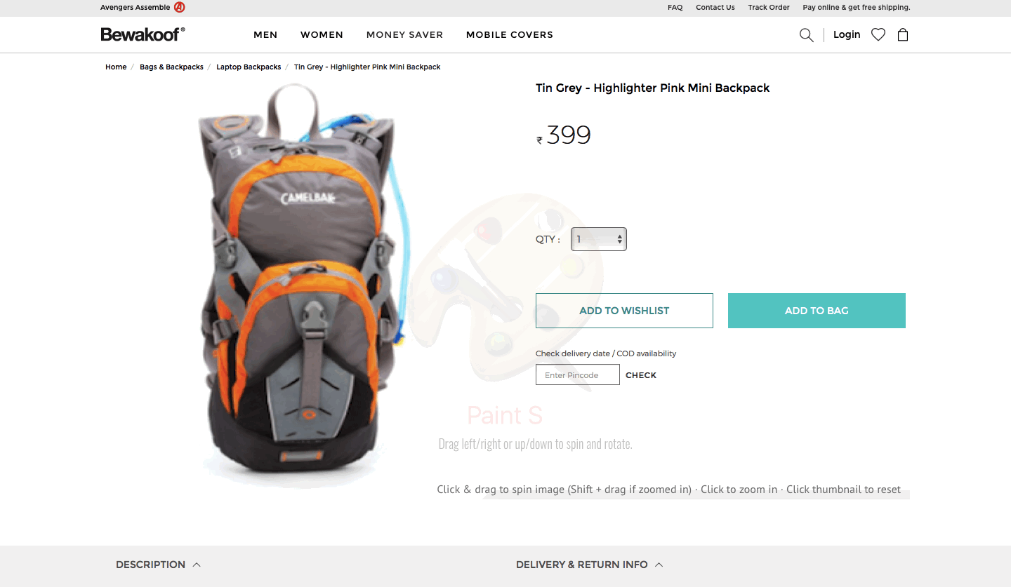

Figure 7: Angle 2 of the product

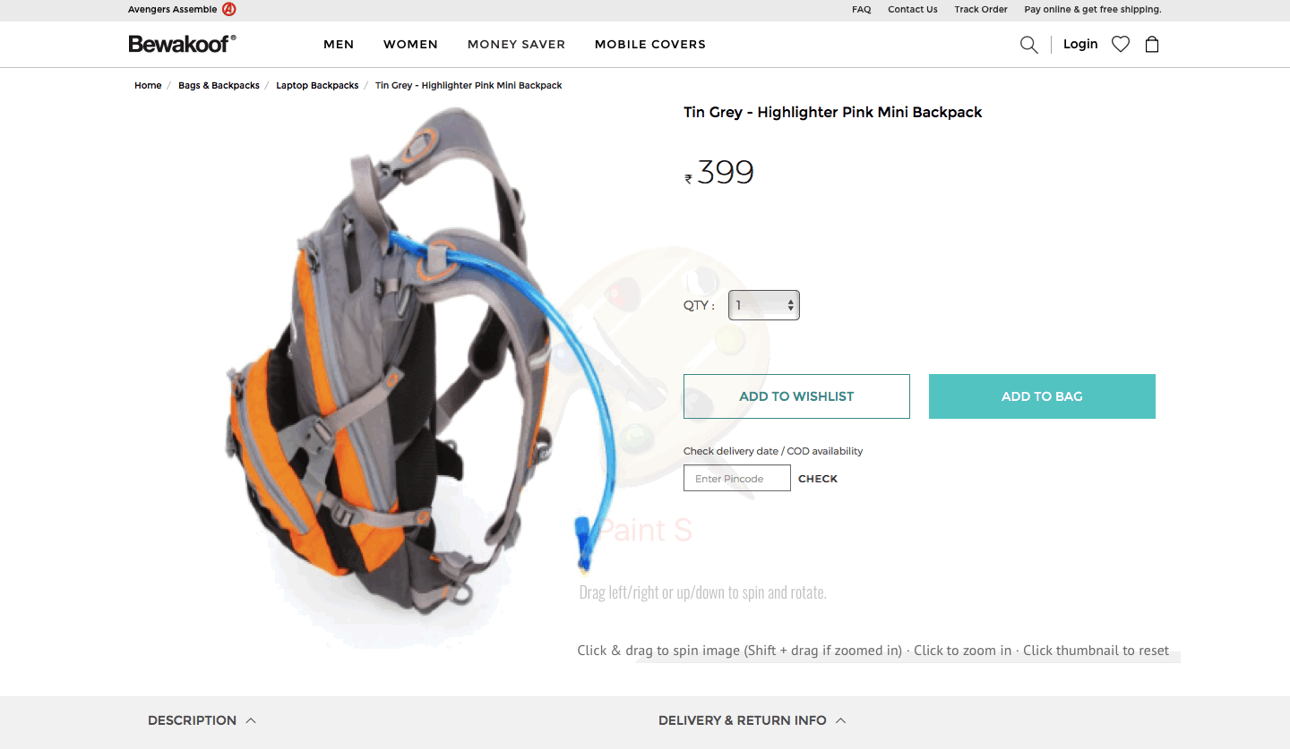

Figure 8: Angle 3 of the product

  
 Figure 9: Drag and Spin feature

Fig 01: “Click and drag to spin image”  
This feature helps a user to view the product clearly by rotating and spinning it over 360 degrees.

## 7.4 Service Transition

Once our Shutter 360 Image Software tool is ready and all the setup procedure are performed. We can start with automating the process for 3D-Image processing or this process can be done in a manual procedure. We will load the 3D -Image file into the database system that will point towards the product index. Everything will be done in a local test environment. This test environment will be then tested by a team of QA testing team and after approval and final testing and Go-ahead from testers then version can be loaded on UAT Server for client and stakeholders. Here heavy testing will be done by stakeholders of the project to check whether 3D-image on websites provides a good UI look and matches criteria for high-quality images. Once all testing is done, this 3D-Images can be loaded on the Production environment. The closing release requires a green signal from the Change Advisory Board (CAB) to go into production. Release and deployment team can handle the release of images on daily basis and take care of process that includes capturing images from 360 Shutter software and uploading on Database system for a proper index on the product [18].

This release builds can be made on a daily basis so that 3D-images are covered for all products for our website. Slowly Release builds can be on hourly basis so our website covers 3D images for more products which are added to our catalog.

## 7.5 Service Operation

The objective of Service operation would be to monitor and control the working of Shutter 360 application and its services. Routine backing up and maintaining a copy of all the images photographed with this software. Making sure that during an emergency, there is a backup of all the images which can be put to use readily using minimum maintenance period. This would be achieved by including a job scheduling for backup and restores activities, print and output management, and routine maintenance of the application.

## 7.6 Continual Service Improvement

Continual service improvement (CSI) is the architecture where the service cycle shows objective in supervising and escalating services including operation, command, capacity and all explained areas that support services. CSI ensures that organization employs in disciplined practices to measure functions. The process within CSI is the 7-step improvement process. The process within CSI will help improve the 3D-image service for our website. Decrease the cost of rendering services and assure that IT services enable the required business outcomes to be achieved [17]. We will identify strategy for improvement that will include to improve image quality and processing of 3D-Modeling which is a manual.

Improvement can include to automate the 3D-Modeling process and directly load the images to database according to image indexing in database. Metrics can included like high availability of database server to load images into system. Higher RAM for database server will guarantee that image load process is faster to HTML and CSS pages. High server connectivity will ensure that image for 3D-modeling system will get updated to Database system. Later we should define performance metrics for key performance indicators for example high availability of servers, 3D-Modeling Shutter Software should be working all the time. Automated Quality checks for Image should be put in place for example , image quality should be greater than 5 Megapixels. Later data can be gathered using dashboard for modeling process that will collect data and analysis can be performed to implement the improvement. Improvements will be done to system in order to enhance productive

# 

# 8. INTERNAL TICKETING SYSTEM (Anali Inamke, Saurabh Pisal)

## There was no system available to trace and register the incoming issues as well as there was a paucity of understanding on how to walk through in incoming issues new and repetitive issues. This created a havoc leading to untracked issues and knowledge base. There was a huge urgency in the creation of a structured and well-organized tracking tool as well as a database for banking knowledge.

## This issue has hit majorly the organization due to the reworking of the same process again and again and costing the organization time as well as money.

## The issue was resolved temporarily by creating a Database where the issues resolved were solved but making It available globally for the organization was missing. Hence an effective tool to resolve the existing system and its structure and availability was required.

## 8.1 Service Strategy

Trying to implement a tool which will record all incoming Requests, Incidents and a shared database for Knowledge creation. A tool which can also produce dashboards and Data analytics based on the history of the issues and help in business / Team strategies. This tool will now save the time consumed to resolve a ticket. The tool is available to everyone in the organization.

An investment in a tool like this is a one time investment for the company and the profit due to the investment will come later in the future. This tool will help in simplifying the process of Tracking.

## 8.2 Service Design

An expertise team was appointed to accomplish the goal to implement this new software to the extant system. After several meetings with the departmental heads, a common solution was made to profoundly understand what services we have that could be impacted by these changes. A change management process owner was assigned to the team to direct the process [19].

A research team was required to learn the effects of not managing the incidents, what are the limitations currently generated due to deficiency of conventional management [19].

Service now as Management tool

The intent of an Incident management tool is to revive any service operation ASAP with the merest impression towards the business operation workflow, maintaining quality and business. Recognition of using Service now are as follows:

Incident logging, Incident classification, Incident Group assignment(see figure abc). This incident management tool will assist to create incidents INC, for incidents which further has the classification of incident depending upon the priority of incident. Further due to service now the issue can be accurately assigned to the team which is related to the affected configuration item. Due to this facility, the work will be properly distributed and can be reached on time towards the team..

Service now has the ability log incidents, classify incidents based on urgency and impact on business, escalate and resolve(see figure 1).

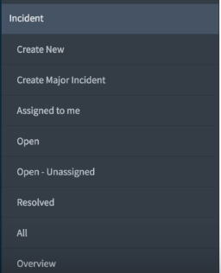

Figure 10: Option available for the user to create ticket

Any user can record an incident assign it to the related group and the person to work on this incident. If it has been wrongly assigned to the group, the group further can verify which group works on the affected CI and can assign it to them. This gives the user the flexibility to review their incidents and even follow up on the same

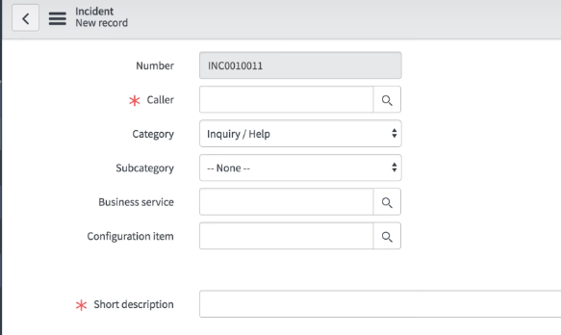

Figure 11 :New Incident view

Incident number is created automatically. Caller is the user which raises the ticket. Category will be the type of incident which will have options such as Inquiry, Service request or help. Subcategory can be blank is not required. Configuration item is the service which has been affected. A short description will note what is the issue in short (see Figure 11)

The contact type will describe who is creating the INC or service request. The user can check the status in the status bar where there will be options like In progress which means there is process going on the requirement, In Progress-Awaiting change which states the ticket has been taken into consideration to resolve but needs a particular change in the system or from other teams to go ahead, In progress-Awaiting Customer : if something in return is required again from the customer or user created the incident /Service request. An email will be triggered to the user who creates this incident if the incident goes in In Progress-Awaiting Customer status. Resolved: if the status is resolved it depicts that the INC has been resolved and waiting for Customer feedback to confirm the resolution. This flow will make sure that each and every incident reported by the user is tapped and resolved in a timely manner. Closed: When a final confirmation has come back from the user created the incident, the ticket can be closed with this status(see figure 12). Cancelled: When the incident was found to be a duplicate incident or rather an unnecessary incident will be put into the state of cancelled.

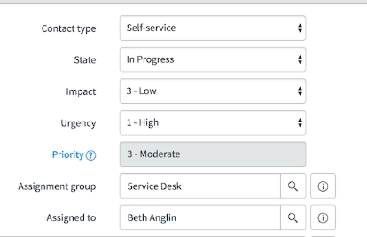

Figure 12: Incident Workflow and Status

The incident also follows with support matrix such as Impact: 1-High, 2-Medium, 3-Low. Priority: 1-Critical, 2-High, 3-Moderate, 4-Low, 5-Planning.

Below is an example on how any particular assignment group can log into service now and have a look at its INC’s (see Figure 13)

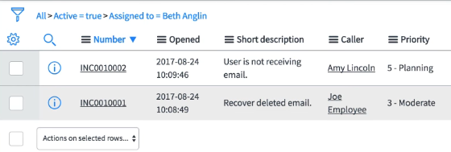

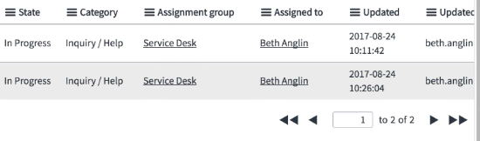

Figure 13: Group Incident requests repository

Before sending any incident into resolved state the close need to be done properly with proper closure notes. The notes can be states in the Resolution notes text box or any Knowledge base article can be created for the same attached to the INC ticket (See Figure 14)

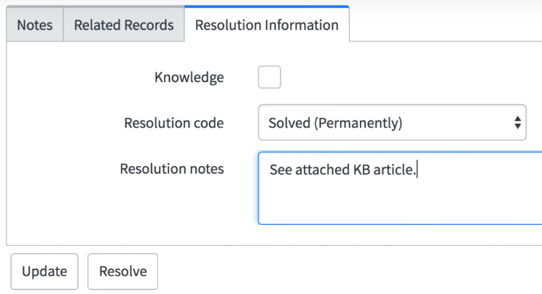

Figure 14: Resolution Information

The SLA of Incidents can also be tracked by the user as well as the team working on the incident via the software directly. This further tells the team in advance how do they need to manage the tickets and resolve it in time(see Figure 15).

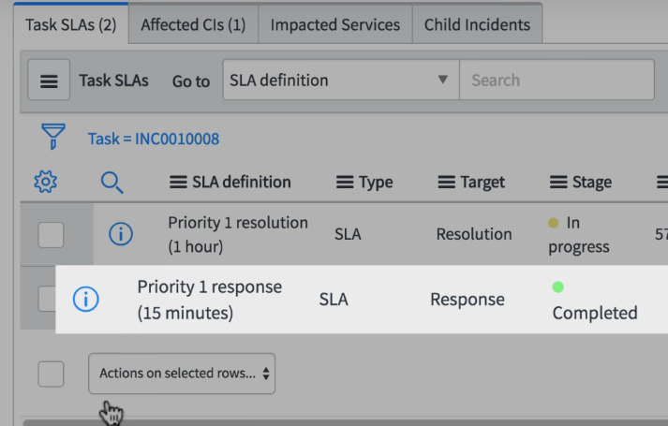

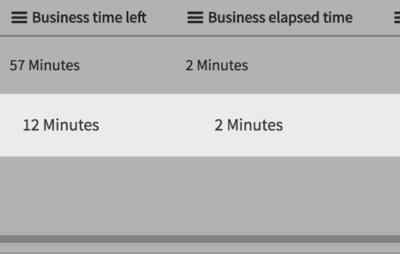

Figure 15: SLA

Knowledge Base

IT: IT individuals add articles to help clients with basic issues.

Understanding information base highlights

Knowledge articles are for interior utilize as it were. Clients must have a login to your Express occurrence to peruse articles in any information base.

Information article creation from occurrences and issues

IT staff and managers can make an information article consequently when an occurrence or issue is shut. A workaround learning article can be made from an open issue. On the off chance that you utilize the article creation include, prepare IT staff to enter clear, exact guidelines about the determination or workaround. Of course, articles made from episodes and issues are set in the General KB. Any article can be moved to an alternate KB. The head can arrange an information base property to change the default to an alternate learning base.

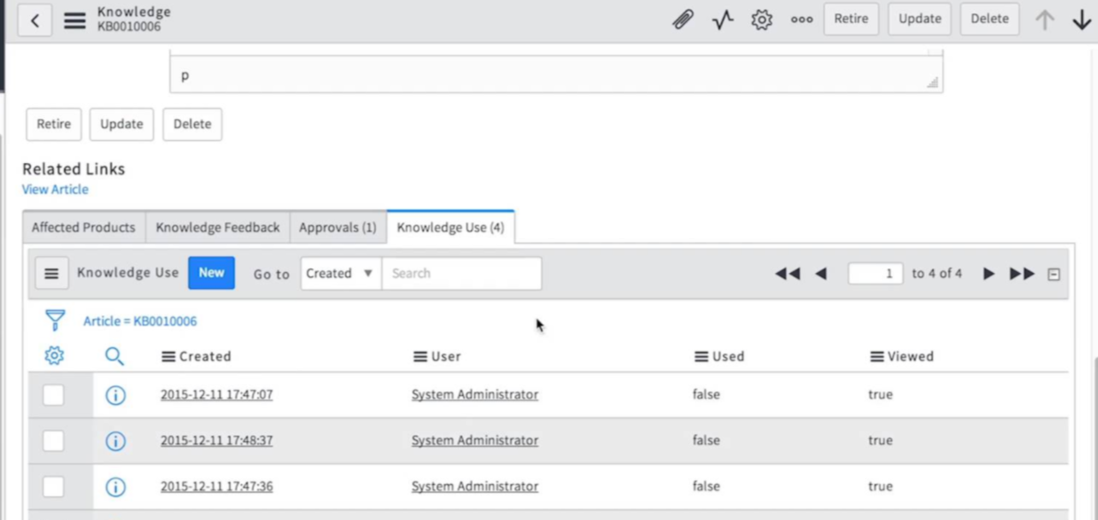

Figure 16: Knowledge Articles adding

Social Q&A gives clients a chance to make inquiries, post and read replies, and vote on the inquiries and answers. The inquiry submitter gets notice when an answer, remark, or vote is gotten, and different clients can buy in to any inquiry and get notices. Social Q&A is configurable for every learning base.

Learning articles, for example, arrangement and advantages documentation, can be transported in from existing .doc and .docx records.

On the off chance that your association enables any client to ask for and deal with an information base, the director includes the Request Knowledge Base record maker to an index class. Any client would then be able to present a demand, for instance, supervisors of various divisions ask for an office KB. At the point when the chairman endorses the demand, a latent KB is made consequently, and the asking for client turns into the proprietor and is conceded the knowledge_manager part.

Learning articles commonly experience the accompanying stages.

A draft is the principal duplicate of an article. A draft may at first contain unpleasant notes yet ought to be as near a completed report as could reasonably be expected. The writer distributes the article, which places it into Review state. Notice is sent to the KB proprietor to audit and support the article. A distributed article is in fact exact and has experienced audit and refresh. Distributed articles show up in the learning base and are noticeable to clients with the fitting client criteria. A resigned article is not any more exact or is outdated. Resigned articles don't show up in the learning base.

The proprietor of an information base and clients with the administrator part can oversee KB articles through the life cycle. Information base proprietors and writers can choose from a few modules to work with articles, for instance, Unpublished or Flagged articles. Learning writers can screen their own substance in My Knowledge Articles under Self-Service.

Clients with the itil part can make information articles from occurrences. They can't alter them or distribute them unless they are the KB proprietor or are conceded giver status.

## 8.3 Service Transition

During the Transition of Servicenow, the legacy system will be replaced during the non working days. A maintenance window will not be required as the implementation will be implemented and tested during non working hours. Testing of ServiceNow will be done over the working days for a Month and a report will be further evaluated to check on amendments and improvements which will be taken care in CSI.

The KB proprietor designs alternatives, for example, regardless of whether new articles are consequently distributed or require audit. On the off chance that articles require audit before they are distributed, the KB proprietor is the commentator and distributor. The KB proprietor additionally chooses whether to permit Social Q&A.

KB proprietors and executives characterize client criteria in the Can Read and Can Contribute related records to indicate who can read and compose articles in the KB. Client criteria can be indicated for offices, gatherings, areas, clients, and parts. On the off chance that no client criteria is indicated, all clients can read, compose, and import articles in the KB.

The proprietor of an information base and clients with the administrator part can oversee KB articles through the life cycle. Information base proprietors and writers can choose from a few modules to work with articles, for instance, Unpublished or Flagged articles. Learning writers can screen their own substance in My Knowledge Articles under Self-Service.

Clients with the itil part can make information articles from occurrences. They can't alter them or distribute them unless they are the KB proprietor or are conceded giver status.

.

## 8.4 Service Operation

Sorting out information articles

Learning articles are composed into classifications and subcategories that further characterize what sort of data is accessible. The Knowledge landing page shows your organization information bases and records highlighted and most valuable and saw articles. You select the KB to scan for articles. Articles can be labeled to make them simple to discover when you look.

If you are utilizing Microsoft Internet Explorer 9 or underneath, the Knowledge application appears to be unique and showcases points and classes rather than classifications and subcategories. On the off chance that you intend to include learning articles utilizing IE9, plan the Knowledge shape to contain the Topic field, so new articles can be ordered appropriately

## 8.5 Continual Service Improvement

CSI phase will include proper working of Service Now and the integration of Knowledge Base within Servicenow. For further Improvement of Service Now an evaluation every week will be created to check on how the INC are reported and if every incident is linked with the KB article or not. This report will be further discussed with the stakeholders to check on its implementation and fruitfulness. Any further implementation in the serview will be taken back into service Transition and Its efficiency will be evaluated.

# 

# 9 CONCLUSION

## In short, the service improvements proposed herein will allow bewakoof.com to overcome the difficulties of ecommerce in India and put the company in a more competitive position to increase their revenue stream in comparison with their competitors.

With the AI Chatbot, the company will manage more efficiently the inquiries of customers, whether complaints or advices and at the same time reduce the budget intended for hiring customer service representatives. This software will incrementally be available in the website, making each iteration more robust and production ready as well as rising awareness incrementally throughout the customer list.

From the research experiments conducted [16] on 3D product presentations using actual images on the consumer experience and purchase decisions in e-commerce environments. It was found out that 3D 360° view presentations are most sensible for consumers accessing through computers where they perceive an increased product value, better consumer experience and most importantly, more likely to purchase.

By implementation of a newly improved Internal Ticketing system, we can accurately track the record of how the Incidents are reported which will further help in deriving Analytics out of it helping the company in an entirely new direction of Intelligence and Analytics. It holds a tremendous promise on business Intelligence part of the company. It further benefits Bewakoof at the granular level which includes each and every corner of the Business Systems and Processes and thus helping to hold the company at a single point of view. Before sending any incident into resolved state the close need to be done properly with proper closure notes

# 10 REFERENCES

# [1] Preethi Chamikutty. 2015. With turnover of Rs 10 crores, Bewakoof.com claims to be a profitable eCommerce venture. (January 2015). Retrieved January 31, 2018 from <https://yourstory.com/2015/01/bewakoof-e-commerce/>

[2] Jain, S. and Kapoor, B., 2012. Ecommerce in India-Boom and the Real Challenges. VSRD International Journal of Business & Management, 2(2), pp.47-53.,doi:10.9790/487X-1812016773

[3] Trips Reddy. 2017. Chatbots for customer service will help businesses save $8 billion per year. (October 2017). Retrieved January 28, 2018 from <https://www.ibm.com/blogs/watson/2017/05/chatbots-customer-service-will-help-businesses-save-8-billion-per-year/>

[4] Hill, Jennifer, W. Randolph Ford, and Ingrid G. Farreras. "Real conversations with artificial intelligence: A comparison between human–human online conversations and human–chatbot conversations." Computers in Human Behavior 49 (2015): 245-250.

[5] Shawar, Bayan Abu, and Eric Atwell. "Chatbots: are they really useful?." In Ldv forum, vol. 22, no. 1, pp. 29-49. 2007.

[6] Klüwer, Tina. "RMRSBot–using linguistic information to enrich a chatbot." In International Workshop on Intelligent Virtual Agents, pp. 515-516. Springer, Berlin, Heidelberg, 2009.

[7] Lucas-Simarro, Jose Luis, Rafael Moreno-Vozmediano, Ruben S. Montero, and Ignacio M. Llorente. "Scheduling strategies for optimal service deployment across multiple clouds." Future Generation Computer Systems 29, no. 6 (2013): 1431-1441.

[8] Shawar, Bayan Abu, and Eric Atwell. "Different measurements metrics to evaluate a chatbot system." In Proceedings of the workshop on bridging the gap: Academic and industrial research in dialog technologies, pp. 89-96. Association for Computational Linguistics, 2007.

[9] Hung, Victor, Miguel Elvir, Avelino Gonzalez, and Ronald DeMara. "Towards a method for evaluating naturalness in conversational dialog systems." In Systems, Man and Cybernetics, 2009. SMC 2009. IEEE International Conference on, pp. 1236-1241. IEEE, 2009.

[10] Moritz, Franka. “Potentials of 3D-Web-Applications in E-Commerce - Study about the Impact of 3D-Product-Presentations.” *2010 IEEE/ACIS 9th International Conference on Computer and Information Science*, 2010, doi:10.1109/icis.2010.25.

[11] Daugherty, Terry, et al. “Consumer Learning and the Effects of Virtual Experience Relative to Indirect and Direct Product Experience.” *Psychology and Marketing*, vol. 25, no. 7, 2008, pp. 568–586., doi:10.1002/mar.20225.

[12] Klein, Lisa R. “Creating Virtual Product Experiences: The Role of Telepresence.” *Journal of Interactive Marketing*, vol. 17, no. 1, 2003, pp. 41–55., doi:10.1002/dir.10046.

[13] Algharabat, Raed, and Charles Dennis. “Using Authentic 3D Product Visualisation for an Electrical Online Retailer.” *Journal of Customer Behaviour*, vol. 9, no. 2, 2010, pp. 97–115., doi:10.1362/147539210x511326.

[14] Li, Hairong, et al. “Impact of 3-D Advertising on Product Knowledge, Brand Attitude, and Purchase Intention: The Mediating Role of Presence.” *Journal of Advertising*, vol. 31, no. 3, 2002, pp. 43–57., doi:10.1080/00913367.2002.10673675.

[15] Kim, Jihyun, et al. “Influences of Online Store Perception, Shopping Enjoyment, and Shopping Involvement on Consumer Patronage Behavior towards an Online Retailer.” *Journal of Retailing and Consumer Services*, vol. 14, no.

[16] S. Hewawalpita and I. Perera. 2018. Effect of 3D product presentation on consumer preference in e-commerce. *Moratuwa Engineering Research Conference (MERCon)*, Moratuwa, pp. 485-490.

[17] Orand, Brady. *Foundations of IT Service Management: with ITIL 2011*. ITILYaBrady, 2013.

[18] Wahida, Banu, et al. “Release and Deployment Management using ITIL.” *Global Journal Of Computer Science and Technology* , vol. 10, no. 15, 2010, pp. 2–8., doi:10.17406/gjcst.

[19] V. H. M. García, J. P. S. Riaño and L. M. M. Estrada, "Lesson learned management model for solving incidents," 2017 12th Iberian Conference on Information Systems and Technologies (CISTI), Lisbon, 2017, pp. 1-6.

doi: 10.23919/CISTI.2017.7975789

# 

# 

# APPENDIX

|  |  |  |  |  |  |
| --- | --- | --- | --- | --- | --- |
|  | Gabriel Garcia | Ajay Joglekar | Mitushi Pradeep | Anali Inamke | Saurabh Pisal |
| 1-5 | R,A,C,I | R,A,C,I | R,A,C,I | R,A,C,I | R,A,C,I |
| 6 | R, A | C | I | I | I |
| 7 | I | R,A | R,A | C | C |
| 8 | I | C | C | R,A | R,A |
| 9 | R,A | R,A | R,A | C,I | C,I |

Table 1: RACI Matrix